Commodore PET/CBM 6502 Ribbon Cable Adapter Rev. 1

**Module Description**

# Introduction

The 6502 Ribbon Cable Adapter is part of the PET Diagnostic Clip assembly. It replaces the actual DIP40 clip, which is available from Mouser etc. for about US$50. It provides a connection of the 6502 µprocessor to a 40 pin box header. The 6502 is inserted into its socket and it is then connected to the socket of the 6502 on the mainboard of the PET.

The Ribbon Cable Adapter (with or without the clip) can remain in the mainboard for normal operation.

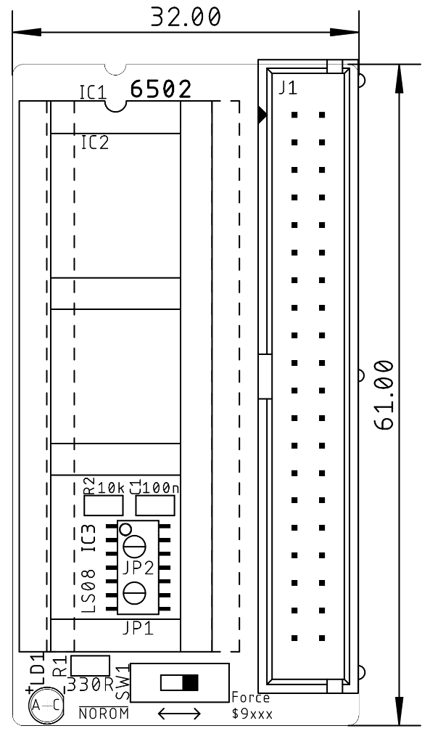

Figure 1: Dimensions of the 6502 Ribbon Cable Adapter

To prevent the need to short circuit the address lines AB13 and AB14 to GND to redirect kernal ROM accesses from $Fxxx to $9xxx (the lower EDIT ROM address space), two AND gates (IC3: 74LS08) are inserted directly after the processor address lines (A13 and A14). This way, the address lines can be set low. This kind of redirection is required for all “non CRTC type PETs, which are not capable to switch off all system ROMs with the /NOROM signal (being low). This feature requires a diagnostic clip rev. 2 (or later).

# Switch SW1

**The switch has to be set to “Force $9xxx” for these non-CRTC mainboards. The CRTC mainboards make use of the /NOROM signal and do not require the said redirection.**

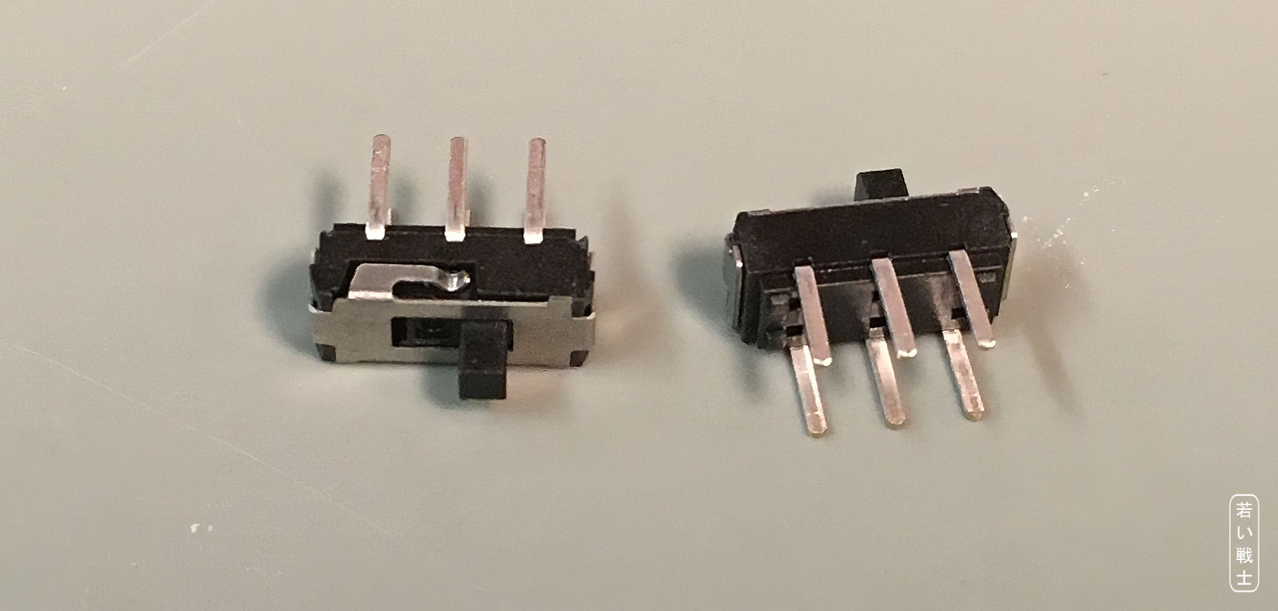

Figure 2: Mini slide switch

These mini slide switches can be found on Amazon, Ebay and AliExpress. A possible search term is “mini slide switch dpdt” or “MSS22D18”, which will not show these switches exclusively, but it should not be too hard to find the right ones.

# Assembly

First, the SMD components are soldered.

The precision round pins should be aligned properly. For this purpose, they are inserted into the DIP40 socket, inserted into the solder pads, soldered one pin each, checked, if they are properly aligned and vertical, adjusted if required and finally soldered completely.

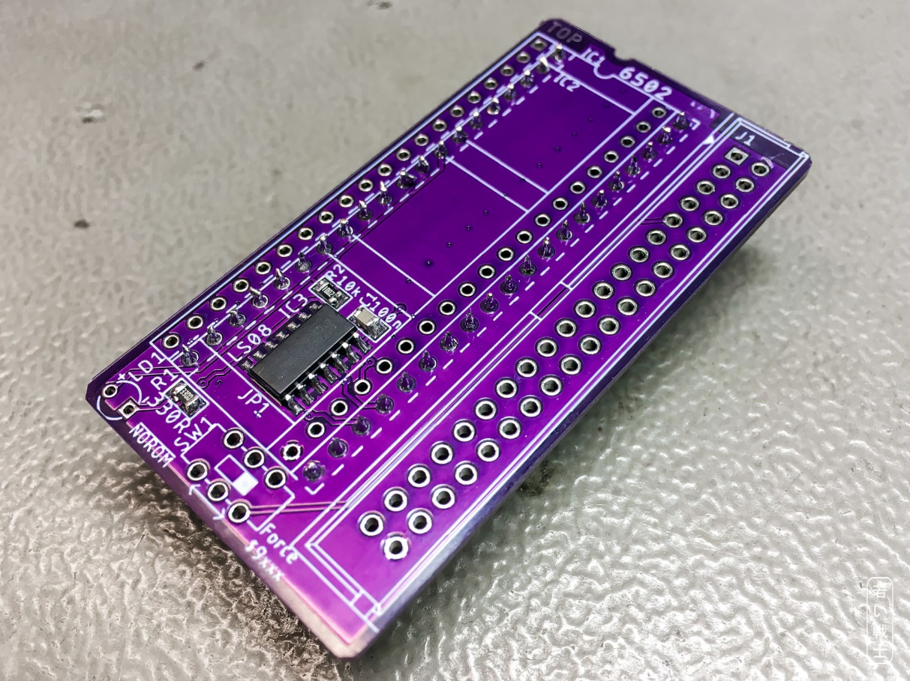

Figure 3: First steps - SMD components and pin strips assembled

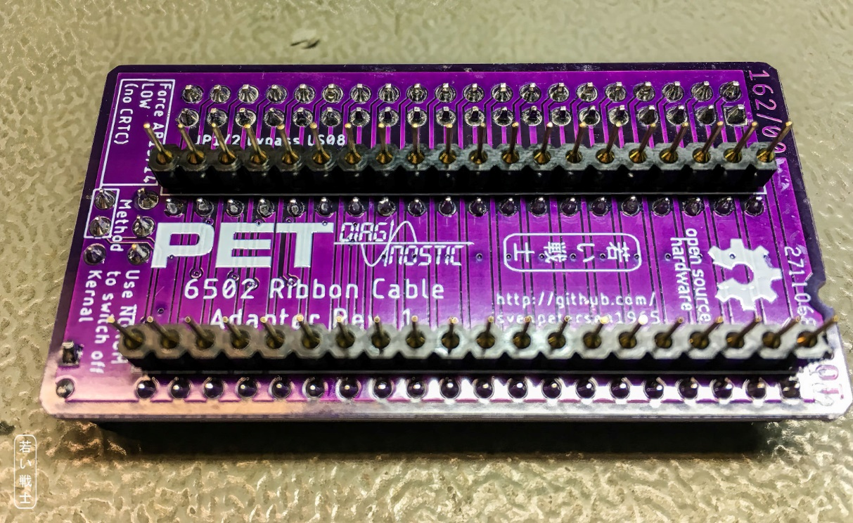

Figure 4: bottom side of the assembled board

# Connectors

## J1 – Clip Connector

| Signal | Pin | Pin | Signal |
| --- | --- | --- | --- |
| GND (6502, Pin 1) | 1 | 2 | /RES |
| RDY | 3 | 4 | PHI2 |
| PHI | 5 | 6 | S.O. |
| /IRQ | 7 | 8 | PHI0 |
| /NOROM | 9 | 10 | n.c. (6502, Pin 36) |
| /NMI | 11 | 12 | n.c. (6502, Pin 35) |
| SYNC | 13 | 14 | R//W |
| 5V | 15 | 16 | DB0 |
| AB0 | 17 | 18 | DB1 |
| AB1 | 19 | 20 | DB2 |
| AB2 | 21 | 22 | DB3 |
| AB3 | 23 | 24 | DB4 |
| AB4 | 25 | 26 | DB5 |
| AB5 | 27 | 28 | DB6 |
| AB6 | 29 | 30 | DB7 |
| AB7 | 31 | 32 | AB15 |
| AB8 | 33 | 34 | AB14 |
| AB9 | 35 | 36 | AB13 |
| AB10 | 37 | 38 | AB12 |
| AB11 | 39 | 40 | GND (6502, Pin 21) |

It is advised to use a ribbon cable, not longer than 15cm and to install the strain reliefs.

## IC1(socket for the 6502, IC2 (6502 pin header)

| Signal | Pin | Pin | Signal |
| --- | --- | --- | --- |
| To J1 Pin 1(GND) | 1 | 40 | /RES |
| RDY | 2 | 39 | PHI2 |
| PHI | 3 | 38 | S.O. |
| /IRQ | 4 | 37 | PHI0 |
| /NOROM | 5 | 36 | To J1, pin 10 |
| /NMI | 6 | 35 | To J1, pin 12 |
| SYNC | 7 | 34 | R//W |
| 5V | 8 | 33 | DB0 |
| AB0 | 9 | 32 | DB1 |
| AB1 | 10 | 31 | DB2 |
| AB2 | 11 | 30 | DB3 |
| AB3 | 12 | 29 | DB4 |
| AB4 | 13 | 28 | DB5 |
| AB5 | 14 | 27 | DB6 |
| AB6 | 15 | 26 | DB7 |
| AB7 | 16 | 25 | AB15 |
| AB8 | 17 | 24 | AB14 |
| AB9 | 18 | 23 | AB13 |
| AB10 | 19 | 22 | AB12 |
| AB11 | 20 | 21 | GND |

The precision round pins are very fragile. It is advised to keep them in a second DIP40 round pin socket.

# Revision History

## Rev. 0

* Working prototype

## Rev. 1

* Tested good with Diagnostic Clip Board Rev. 2